Name: Sourav Nandi

EmailId: souravnandi980@gmail.com

**Project Name:** Perform Software reverse engineering of the executable binaries

**Project Goal:** To reverse engineer given executable binaries (ELF or PE files) and obtain their corresponding high level source codes.

**Project Tasks:**

a) Reverse engineer the binaries to obtain their high level source codes.

b) Determine the objectives of the reversed engineered source codes.

c) Recompile the reverse engineered source codes into executable binaries and verify that they have behave exactly like the original binaries.

**Tools Requirement for the Accompolishment:**

1. Ghidra by NSA
2. Orcale Virtual box(KaliLinux)

**Executable binaries**

https://g25.tcsion.com/LX/INDEXES/AppLaunchSAML/?id=13884&c_id=discussion-room-cyber-security-essentials-cohort-1-14972313-33044&post=medias&app_id=9519&org_id=33044&serviceid=3&mtop_create_lkey=true&comm_target_orgId=33044

------------------------------------------------------------------------------------------------------------------------------------------

------------------------------------------------------------------------------------------------------------------------------------------

**Reverse engineer the binaries to obtain their high level source codes**

There are three binary files named as C2, C3 and C4.

1. ***Kali linux installtion on the Oracle virtual Box and import the binaries***.

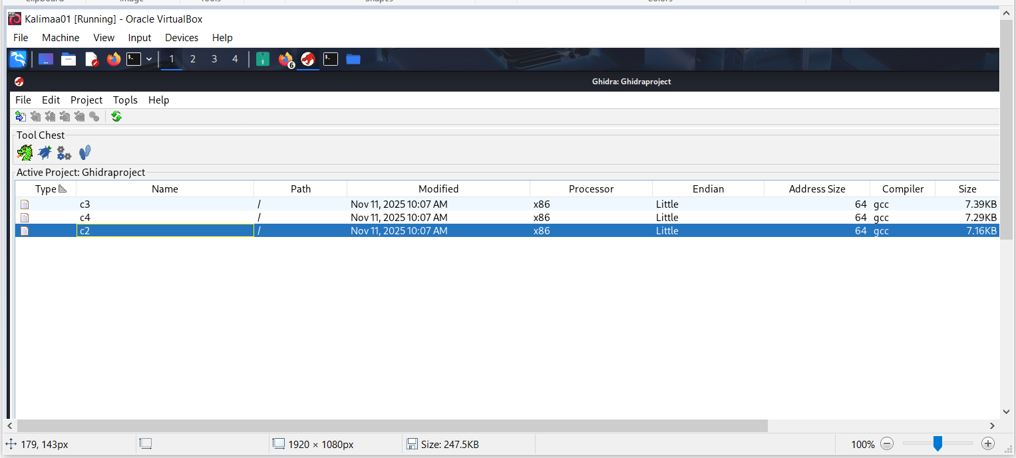

1. ***Run the Auto-Analyzer for C2, C3 and C4***:

C2:

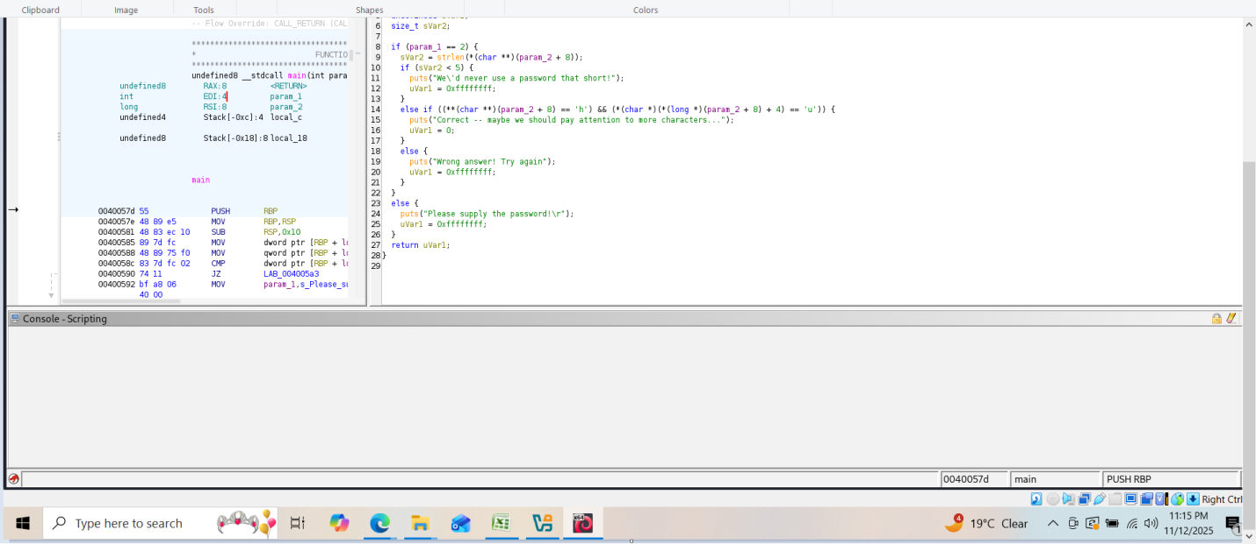

C3:

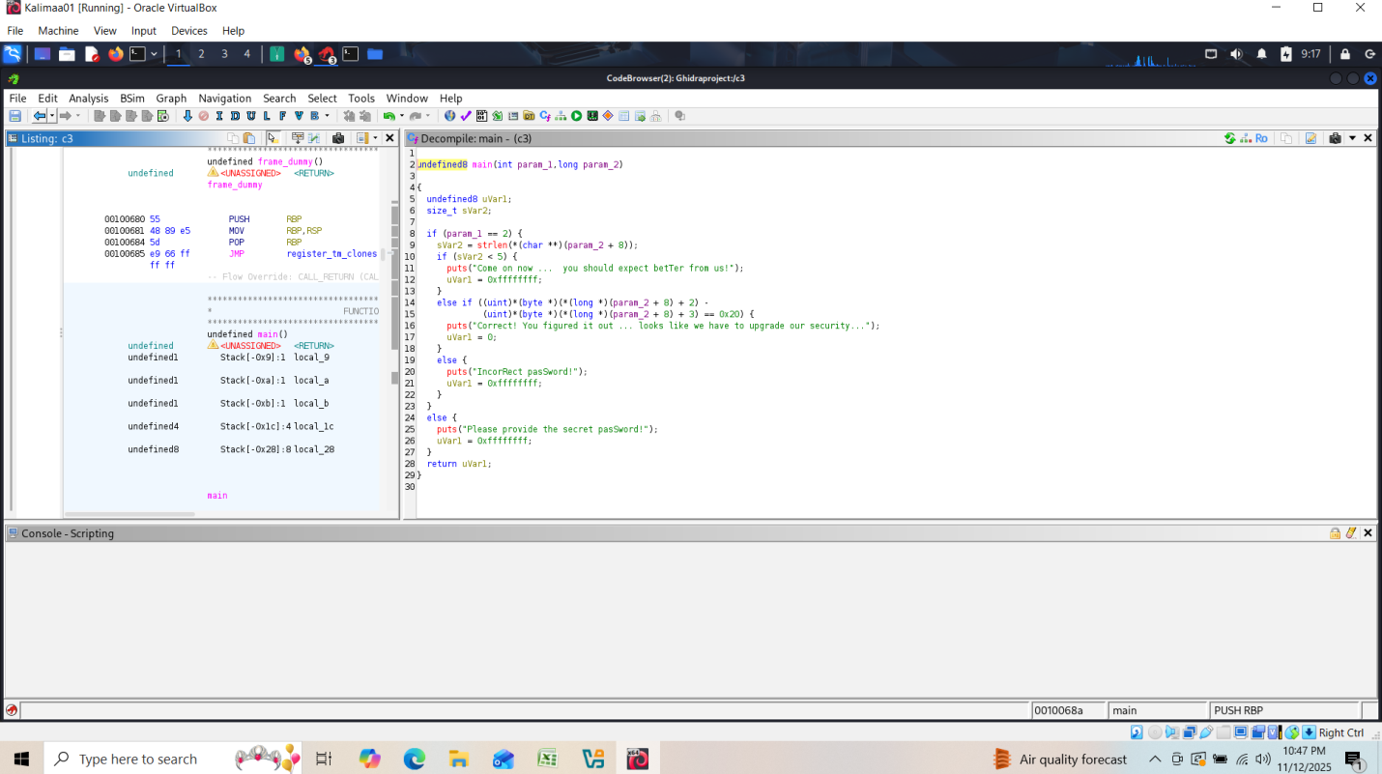

C4:

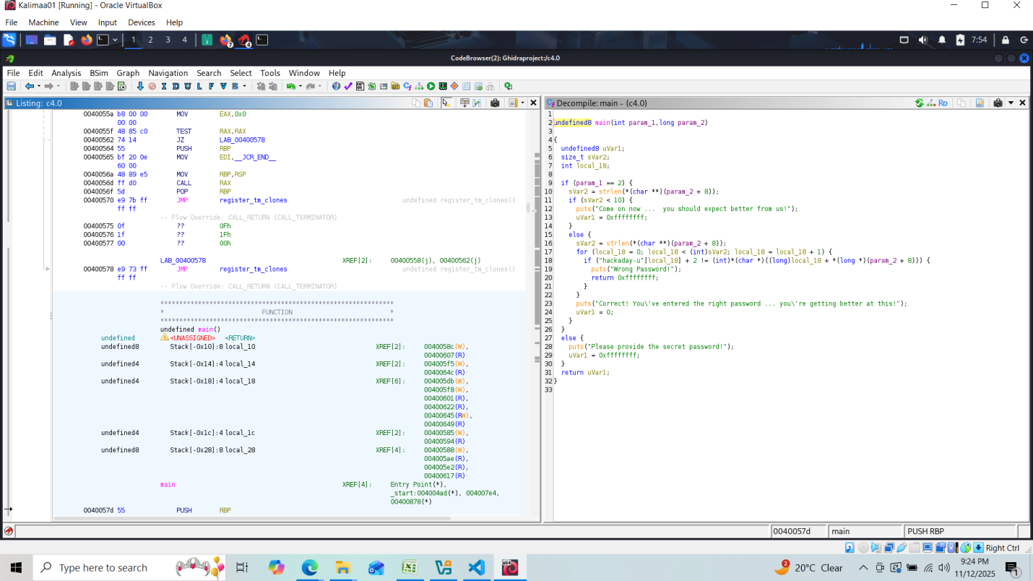

1. ***Fetch Metadata for the Binaries***:

C2: 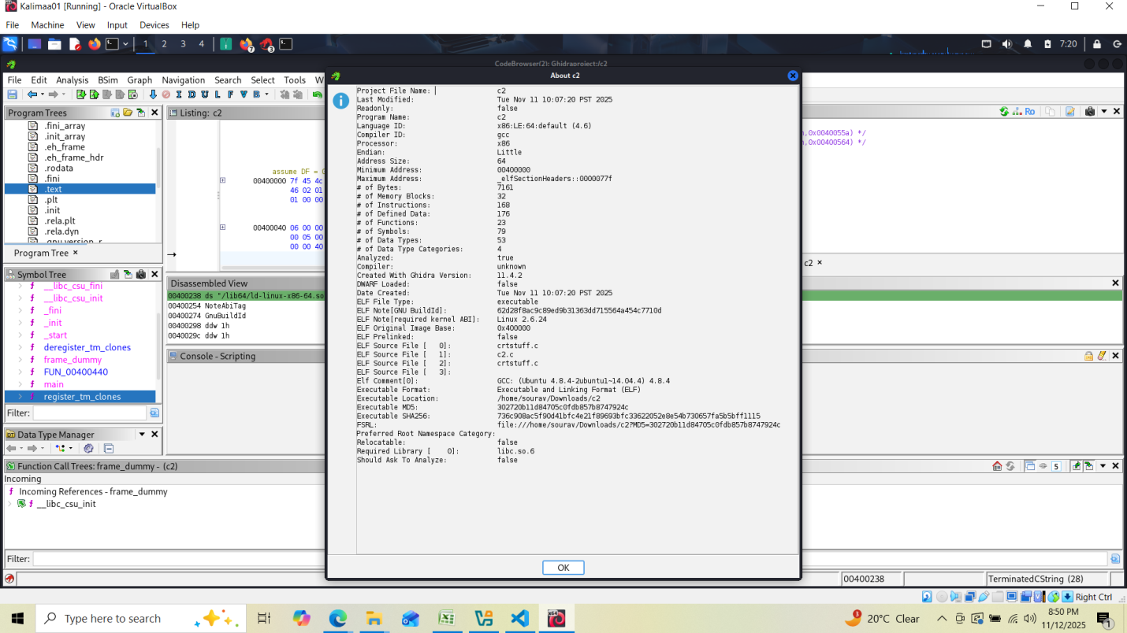

C3: 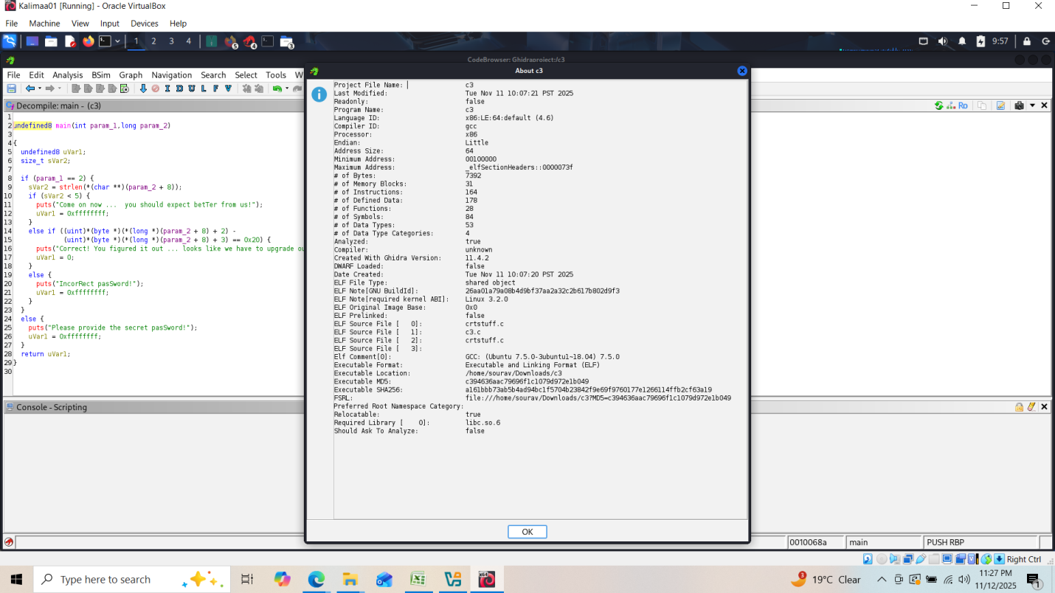

C4: 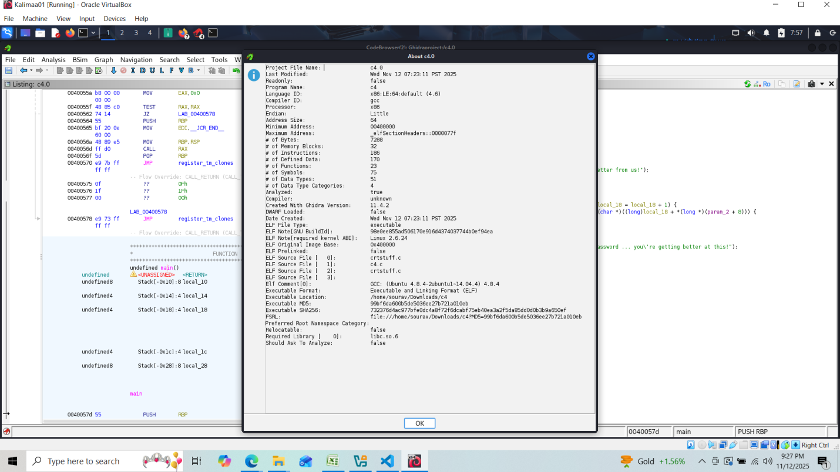

1. ***Function Details:***

C2: 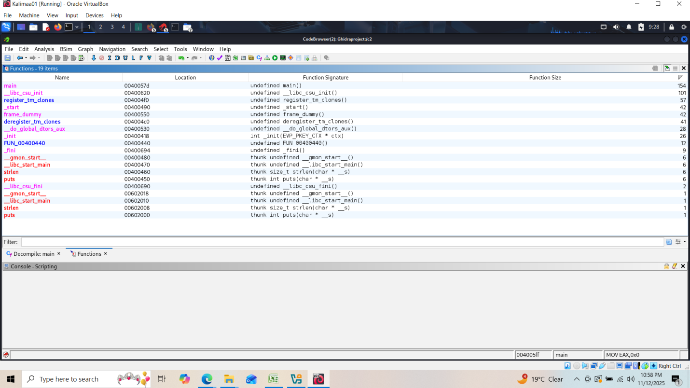

C3: 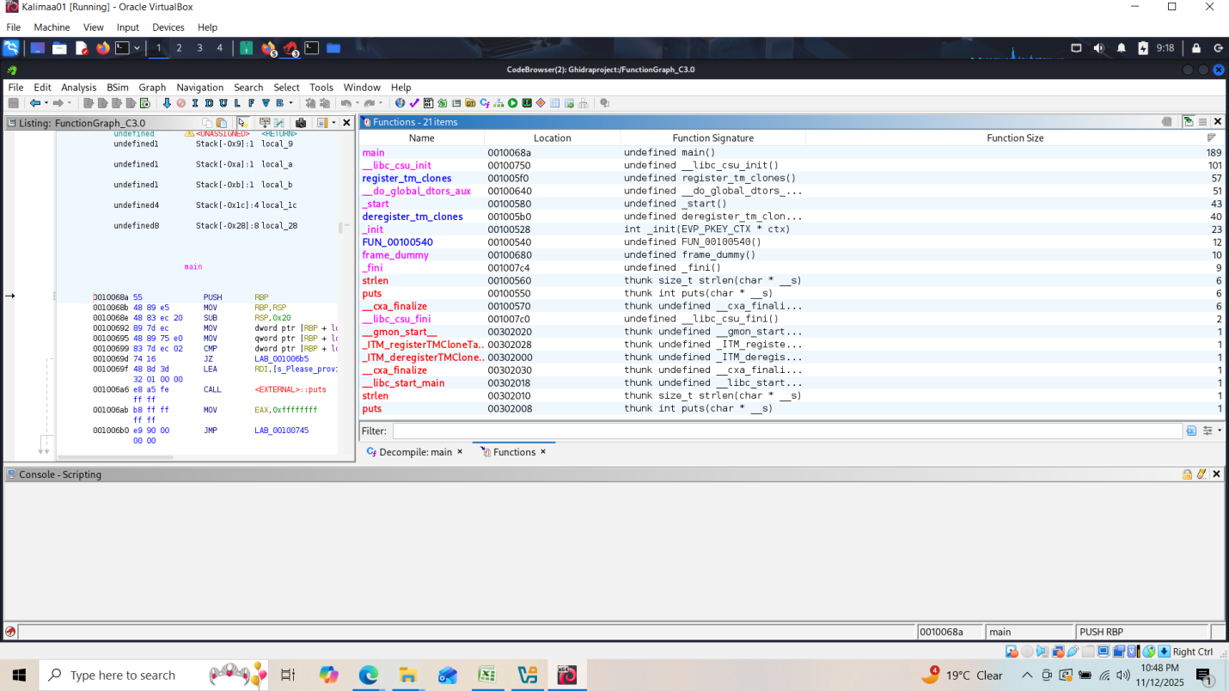

C4: 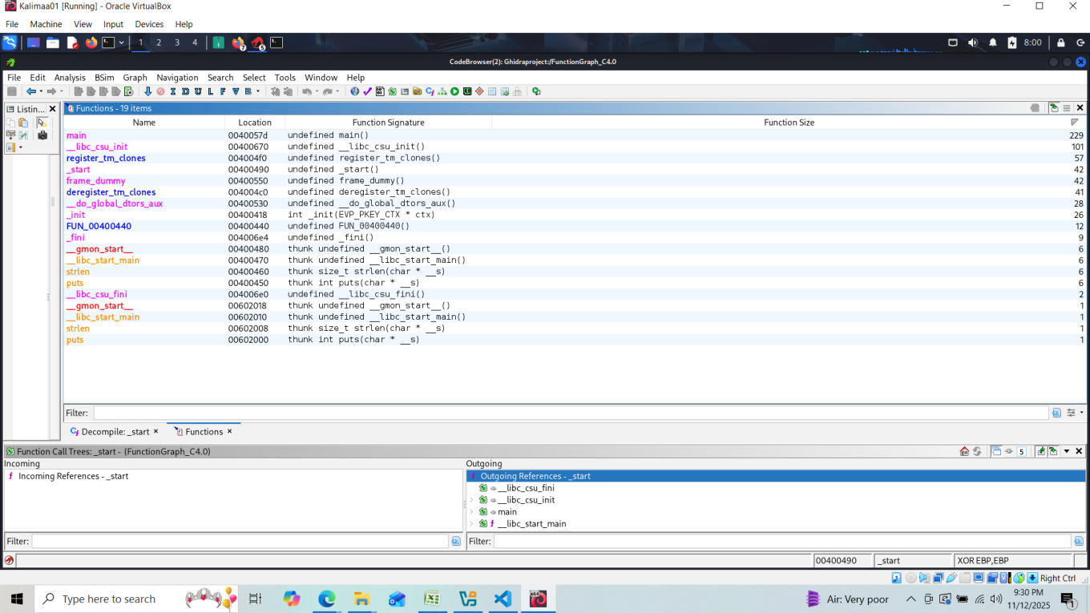

5.

1. ***String View***:

C2: 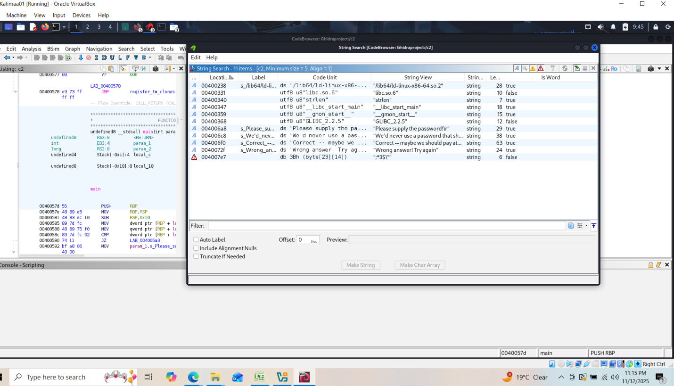

C3: 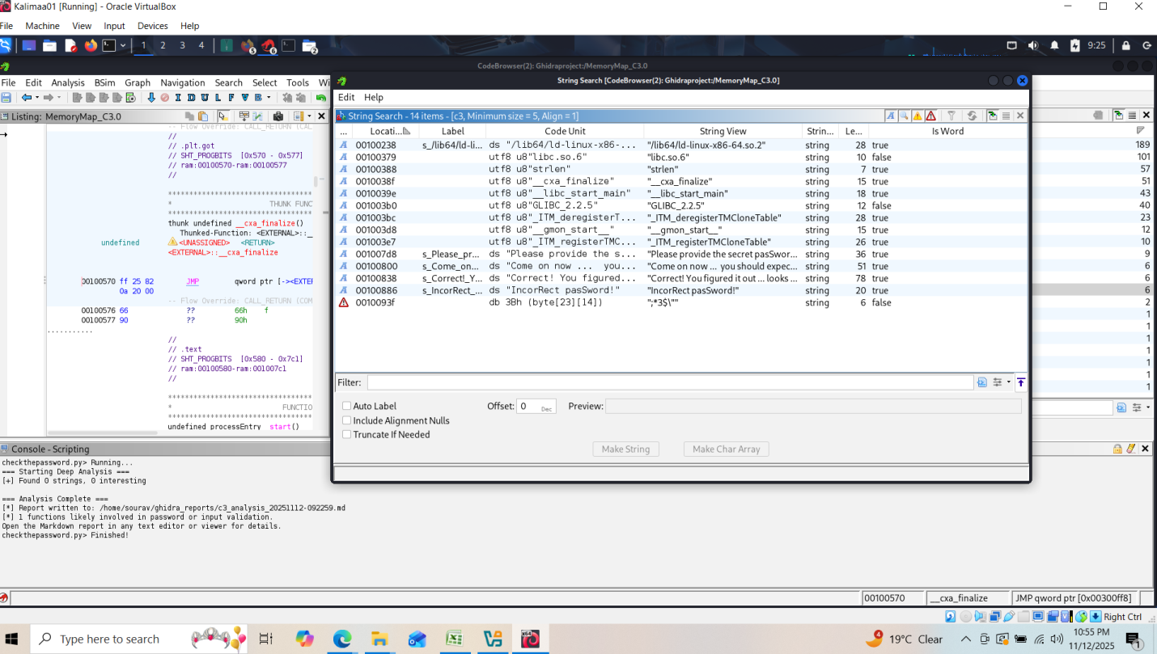

C4

C4

C4: 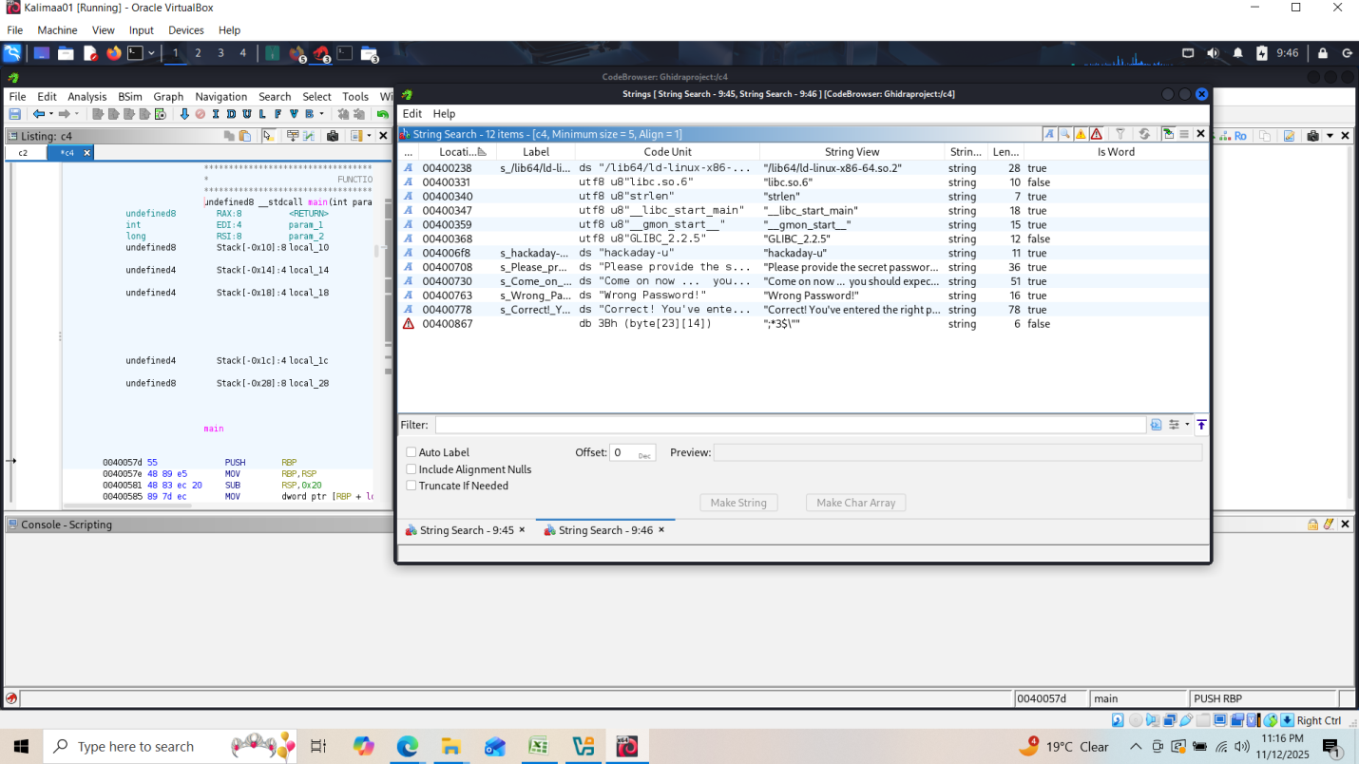

1. ***SymbolTree:***

C2: 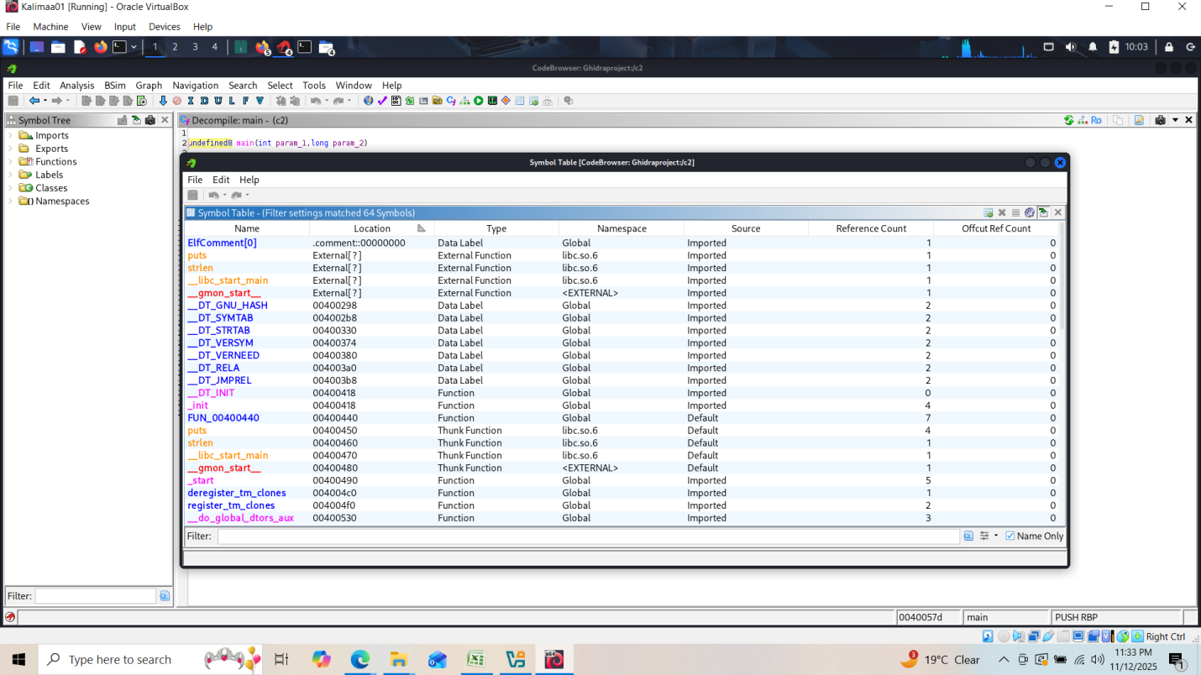

C3: 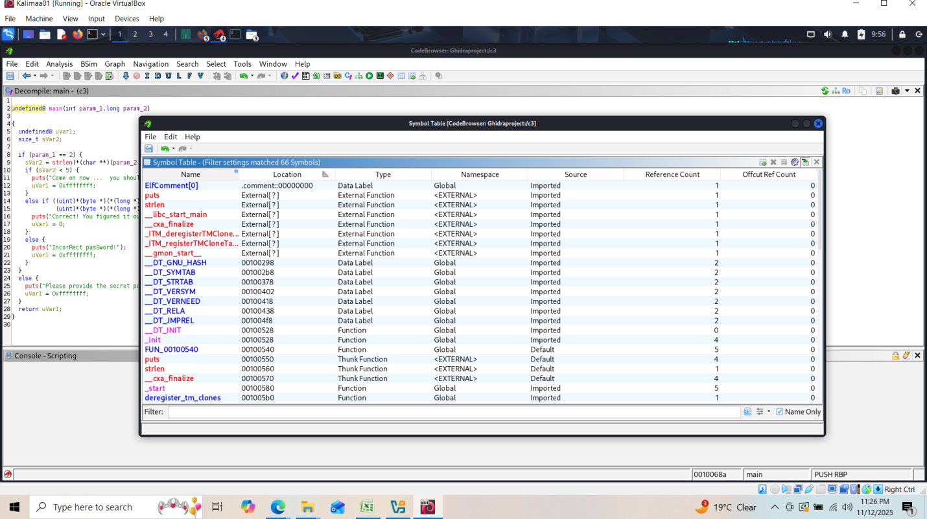

C4: 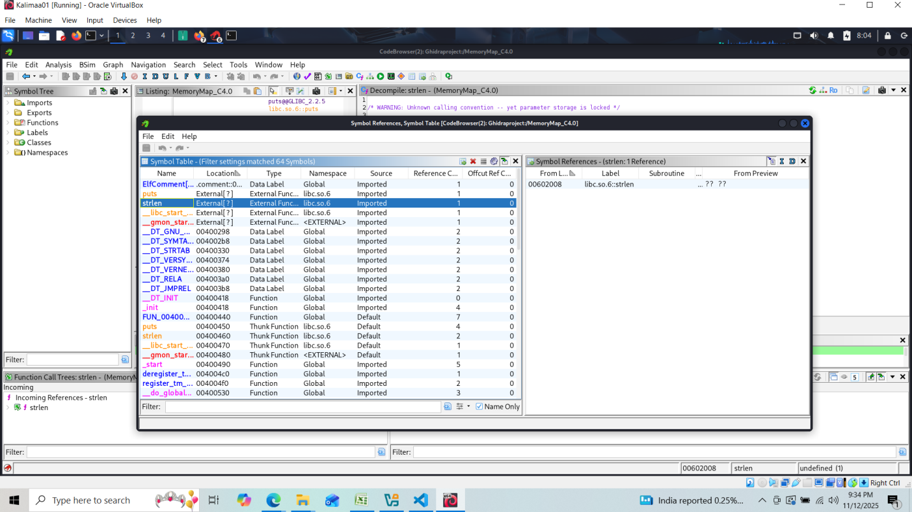

1. Checksum:

C2: 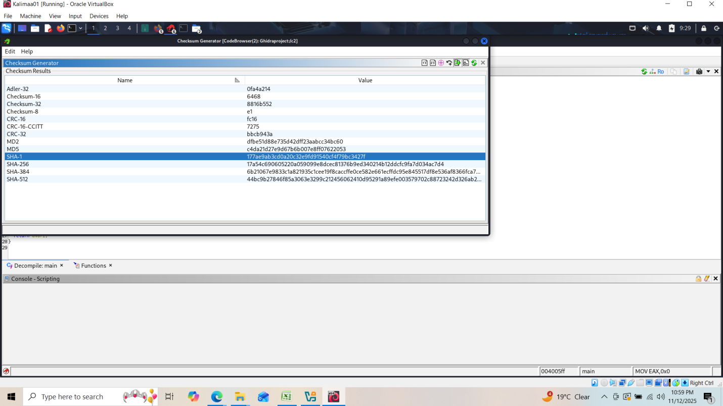

C3

C3

C3: 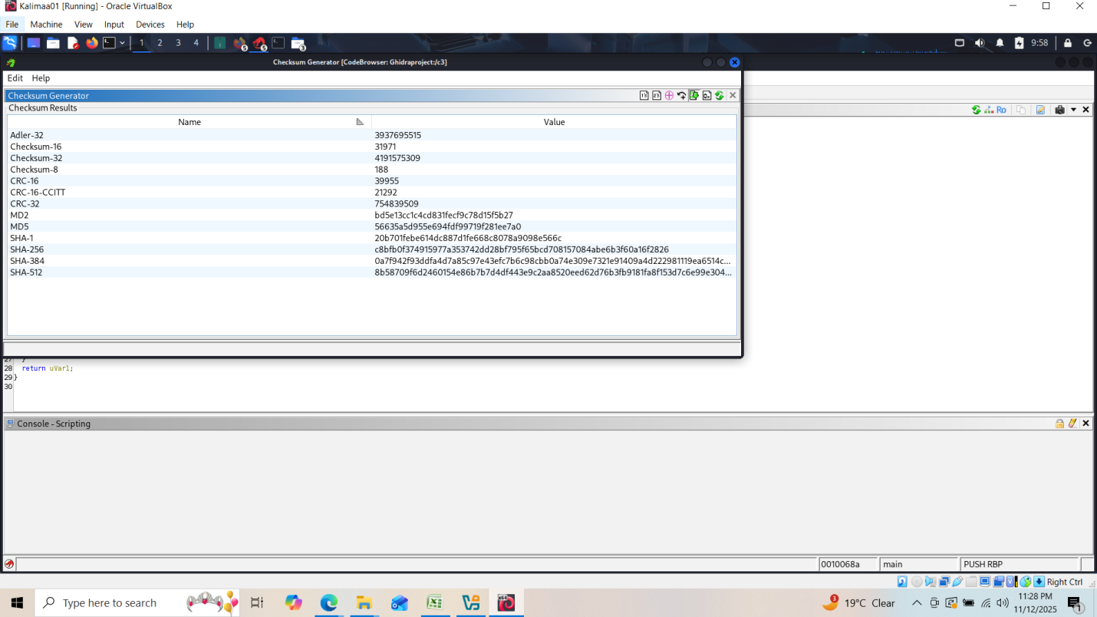

C4: 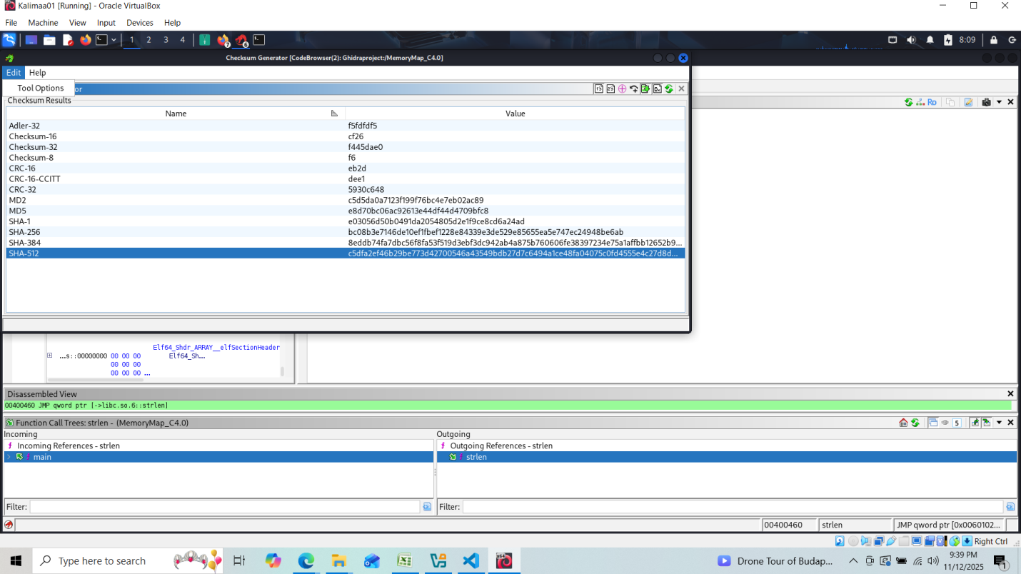

**------------------------------------------------------------------------------------------------------------------------------------------------------------------------------------------------------------------------------------------------------------------------------------**

**Determine the objectives of the reversed engineered source codes.**

*Objectives:*

1. Scan all defined strings in memory.

2. Flags any string containing “password”, “wrong”, “try again”, “correct”

3. Byte comparison

To achieve the objectives, gython script has been created and executed for each C2, C3 and C4 files and stored the findings in the markdown file as below.

*Script:*

# -*- coding: utf-8 -*-

# advanced_report_generator.py

# Purpose: Deep analysis + Markdown report of possible password checking logic in ELF binaries.

# Runs inside Ghidra (Jython-based).

from ghidra.program.model.symbol import SourceType

from ghidra.util.task import TaskMonitor

from ghidra.program.model.listing import CodeUnit

from ghidra.app.decompiler import DecompInterface, DecompileOptions

import os, re, time, codecs

monitor = TaskMonitor.DUMMY

listing = currentProgram.getListing()

program_name = currentProgram.getName()

timestamp = time.strftime("%Y%m%d-%H%M%S")

outdir = os.path.expanduser("~/ghidra_reports")

report_path = os.path.join(outdir, "%s_analysis_%s.md" % (program_name, timestamp))

if not os.path.exists(outdir):

try:

os.makedirs(outdir)

except Exception as e:

print("[!] Could not create output directory %s: %s" % (outdir, e))

def safe_name(s):

# keep resulting function name safe and reasonably short

return re.sub(r'[^0-9A-Za-z_]', '_', s)[:60]

def find_strings(min_len=4):

"""Find defined string-like data items in the program listing."""

results = []

it = listing.getDefinedData(True)

while it.hasNext():

d = it.next()

try:

val = d.getValue()

if isinstance(val, str) and len(val) >= min_len:

results.append((d.getMinAddress(), val))

except Exception:

# ignore non-string data or odd types

pass

return results

def analyze_byte_comparisons(func):

"""

Heuristic: look for MOV of byte-sized source into something followed by CMP.

Returns list of (mov_instruction, cmp_instruction) pairs.

"""

try:

ins_iter = listing.getInstructions(func.getBody(), True)

except Exception:

# fallback: try iterating instructions by address set iterator

return []

findings = []

prev = None

for ins in ins_iter:

try:

mnem = ins.getMnemonicString().upper()

except Exception:

continue

if mnem in ("MOVZX", "MOVSX", "MOVSXD", "MOV"):

prev = ins

elif mnem == "CMP" and prev:

try:

prev_txt = prev.toString()

# crude check for byte-sized move

if "BYTE PTR" in prev_txt.upper() or "BYTE" in prev_txt.upper():

findings.append((prev, ins))

except Exception:

pass

prev = None

else:

# reset prev for non-matching sequences to avoid long carry-over

prev = None

return findings

# create and reuse decompiler interface (slightly heavier but better than recreating repeatedly)

_decomp_iface = None

def decompile_function(func, timeout=60):

global _decomp_iface

if _decomp_iface is None:

_decomp_iface = DecompInterface()

opts = DecompileOptions()

_decomp_iface.setOptions(opts)

_decomp_iface.openProgram(currentProgram)

try:

res = _decomp_iface.decompileFunction(func, timeout, monitor)

if res and res.decompiledFunction:

return res.getDecompiledFunction().getC()

except Exception:

pass

return None

print("=== Starting Deep Analysis ===")

strings = find_strings()

# broaden keywords to catch more password-related strings

keywords = ["password", "passwd", "try again", "wrong", "incorrect", "correct", "login", "auth", "authenticate"]

interesting = [(addr, s) for addr, s in strings if any(k in s.lower() for k in keywords)]

print("[+] Found %d strings, %d interesting" % (len(strings), len(interesting)))

functions = list(currentProgram.getFunctionManager().getFunctions(True))

suspicious_funcs = []

report_lines = []

report_lines.append("# Ghidra Binary Analysis Report: `%s`" % program_name)

report_lines.append("Generated on %s\n" % time.strftime('%Y-%m-%d %H:%M:%S'))

report_lines.append("## 1. Interesting Strings\n")

if interesting:

for addr, s in interesting:

report_lines.append("- `%s` @ `%s`" % (s, addr))

else:

report_lines.append("*(No obvious password-related strings found)*")

report_lines.append("\n## 2. Functions with Byte-by-Byte Comparison Patterns\n")

for func in functions:

try:

matches = analyze_byte_comparisons(func)

except Exception:

matches = []

if matches:

suspicious_funcs.append(func)

# annotate the function in the listing (best-effort)

try:

listing.setComment(func.getEntryPoint(), CodeUnit.PLATE_COMMENT,

"Byte comparison pattern detected — possible password check.")

except Exception:

pass

# try to give a clearer name, but don't overwrite meaningful names if SourceType prohibits

try:

new_name = "check_" + safe_name(func.getName())

func.setName(new_name, SourceType.ANALYSIS)

except Exception:

# ignore failures to rename (e.g., already named or locked)

pass

report_lines.append("### Function `%s` @ `%s`" % (func.getName(), func.getEntryPoint()))

for mov, cmp_ in matches[:10]:

try:

report_lines.append("- `%s` → `%s`" % (mov.toString(), cmp_.toString()))

except Exception:

# fall back to addresses if toString() fails

report_lines.append("- `%s` → `%s`" % (mov.getAddress(), cmp_.getAddress()))

# attempt decompilation (best-effort)

code = decompile_function(func)

if code:

snippet = "\n".join(code.splitlines()[:80])

report_lines.append("\n```c\n" + snippet + "\n```\n")

else:

report_lines.append("*(Decompilation unavailable or failed for this function)*")

if not suspicious_funcs:

report_lines.append("*(No byte-compare patterns found)*")

report_lines.append("\n## 3. Summary\n")

report_lines.append("- Total strings found: **%d**" % len(strings))

report_lines.append("- Functions with byte-compare logic: **%d**" % len(suspicious_funcs))

report_lines.append("\nReport generated automatically by Ghidra Jython script.\n")

# Write out the report using codecs to ensure UTF-8 works in environments without 'encoding' kw arg.

try:

with codecs.open(report_path, "w", "utf-8") as f:

f.write("\n".join(report_lines))

print("\n=== Analysis Complete ===")

print("[*] Report written to: %s" % report_path)

print("[*] %d functions likely involved in password or input validation." % len(suspicious_funcs))

print("Open the Markdown report in any text editor or viewer for details.")

except Exception as e:

print("[!] Failed to write report to %s: %s" % (report_path, e))

# fallback: attempt a simpler write without codecs

try:

with open(report_path, "w") as f:

f.write("\n".join(report_lines))

print("[*] Report written (fallback) to: %s" % report_path)

except Exception as e2:

print("[!] Final failure writing report: %s" % e2)

*Findings:*

C2:

**Executed Script:**

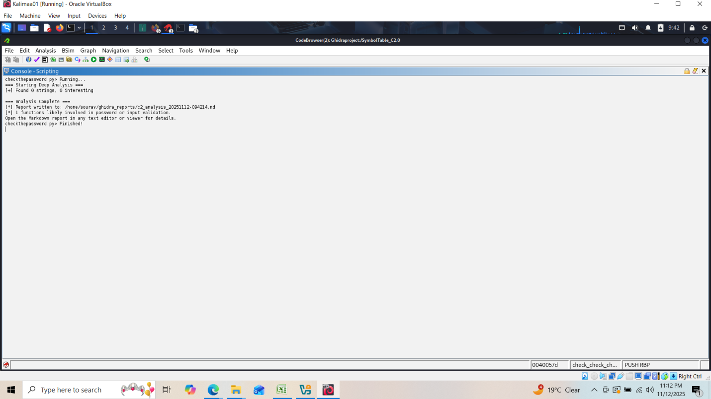

**Markdown File**:

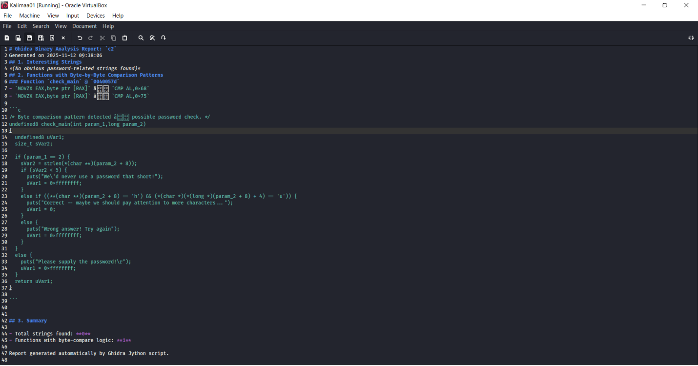

C3:

**Executed Script:**

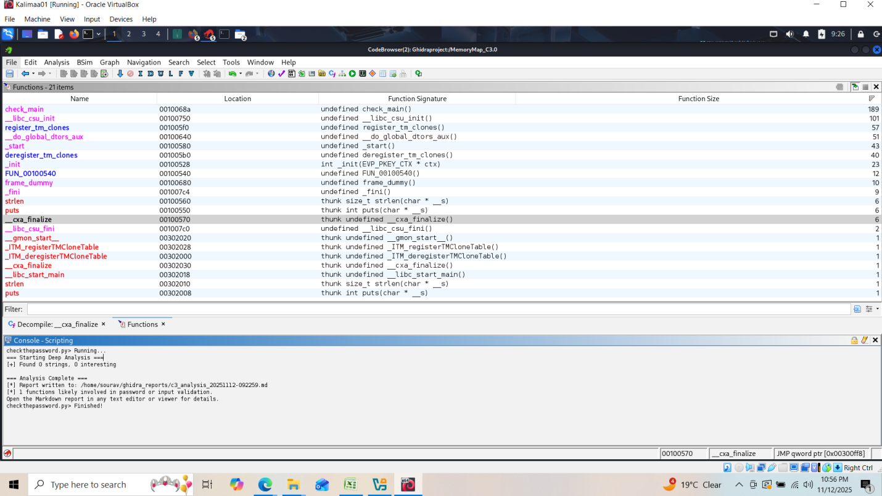

**Markdown File**:

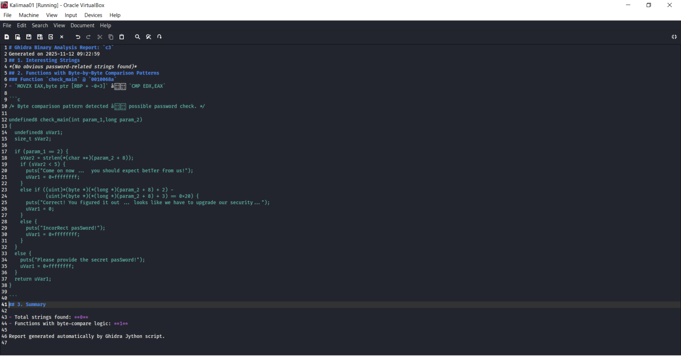

C4:

**Executed Script:**

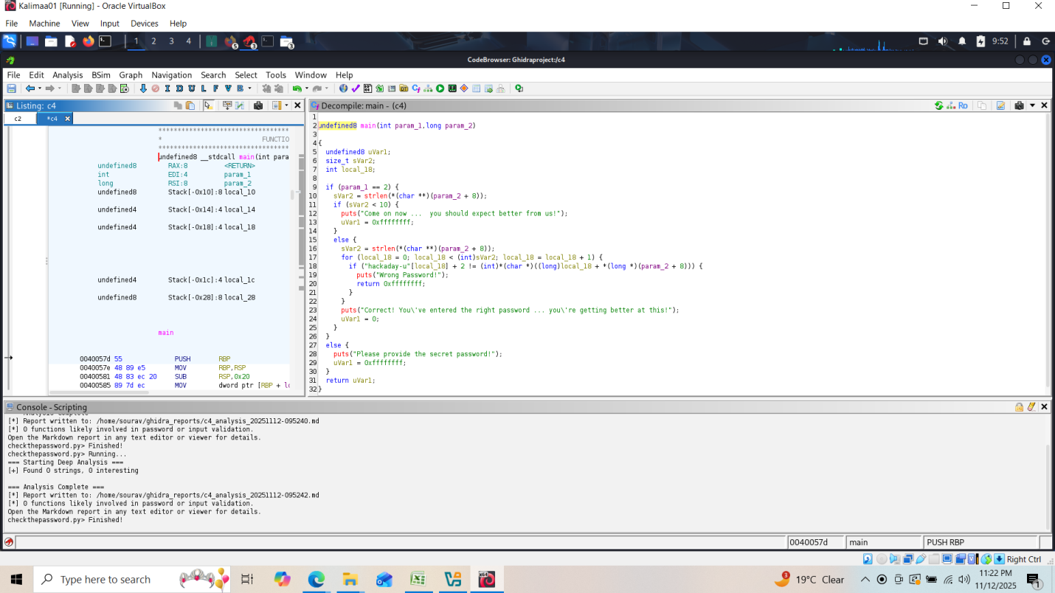

**Markdown File**:

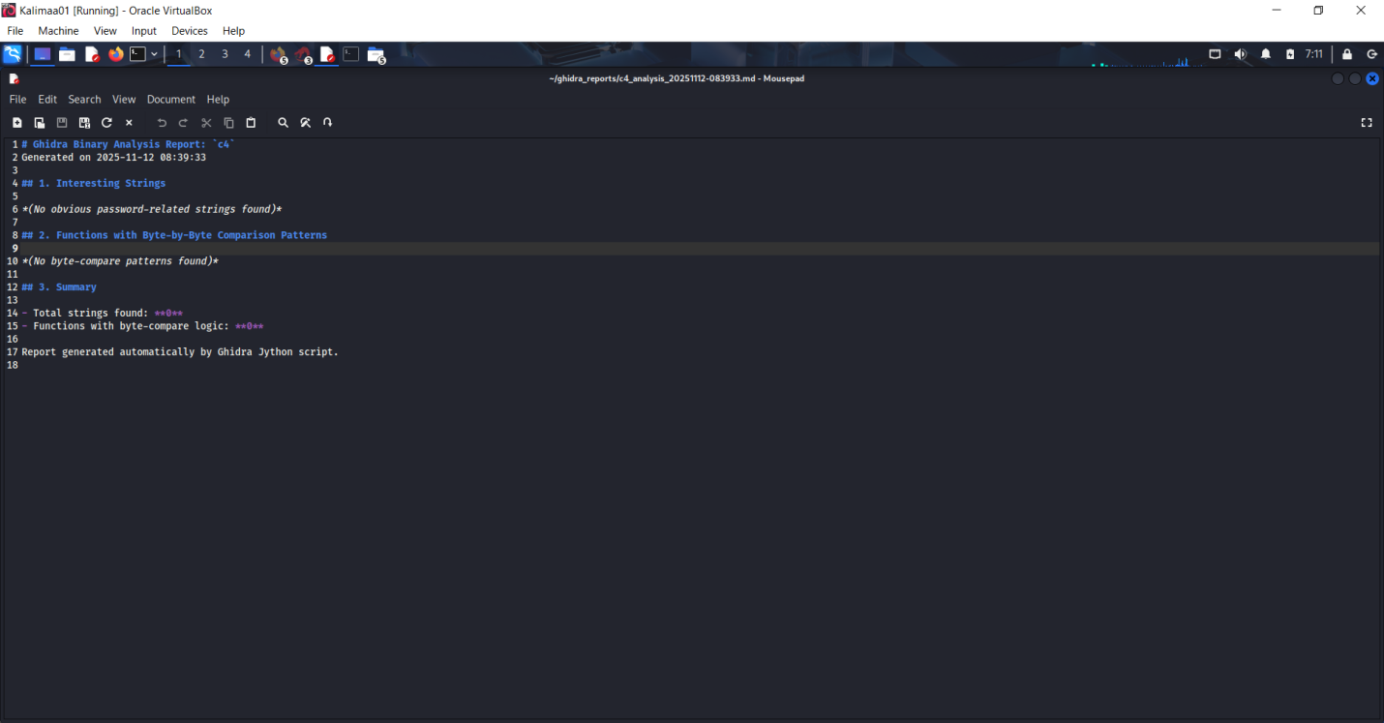

--------------------------------------------------------------------------------------------------------------------------------------------------------------------------------------------------------------------------------------------------------------

**Recompile the reverse engineered source codes into executable binaries and verify that they have behave exactly like the original binaries**

**Objective:** Recompile the reverse engineered source codes into executable binaries and verify that they have behave exactly like the original binaries

To achieve the above task, generate the .c file for each C2, C3 and C4 and and then compile with gcc command and then test by passing arguments:

C2:

***Binary File:***

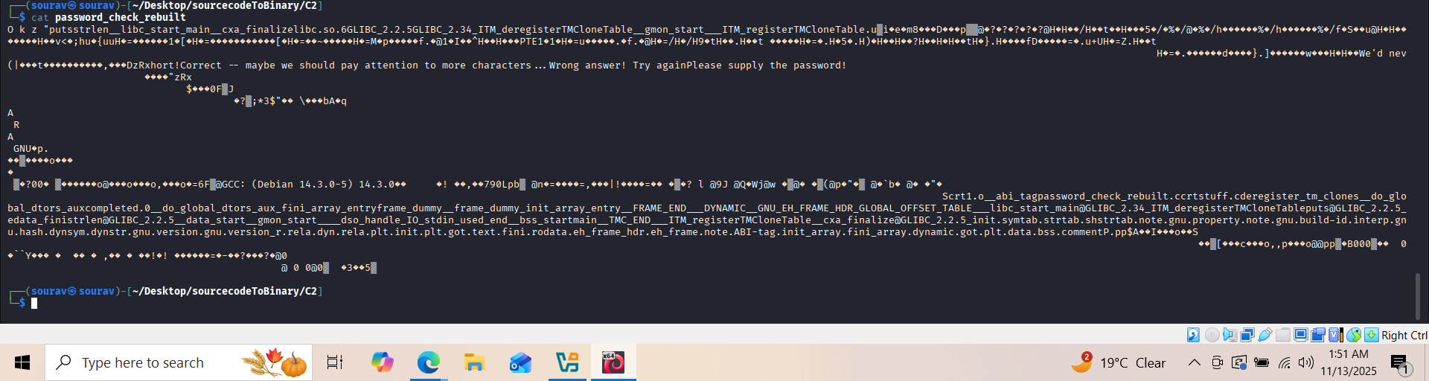

***TestResult:***

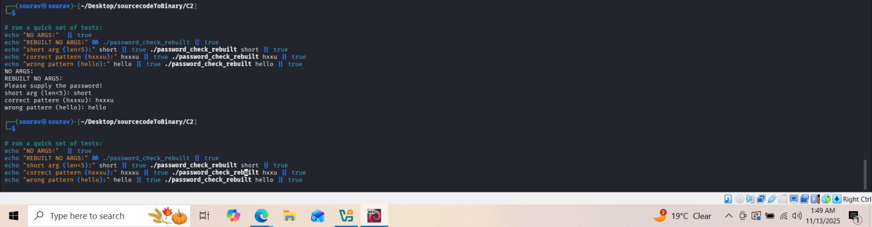

C3:

***Binary File:***

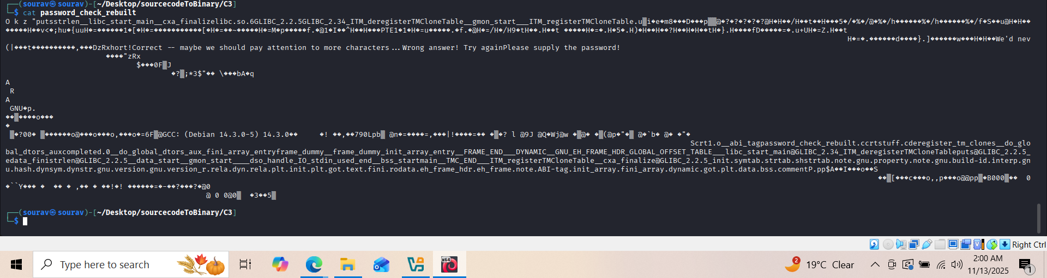

***TestResult:***

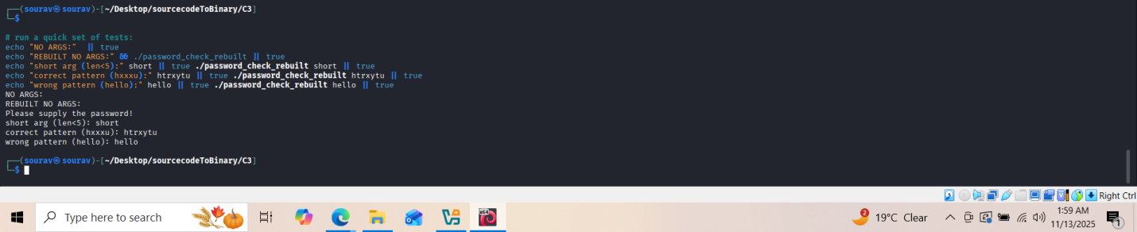

C4:

***Binary File:***

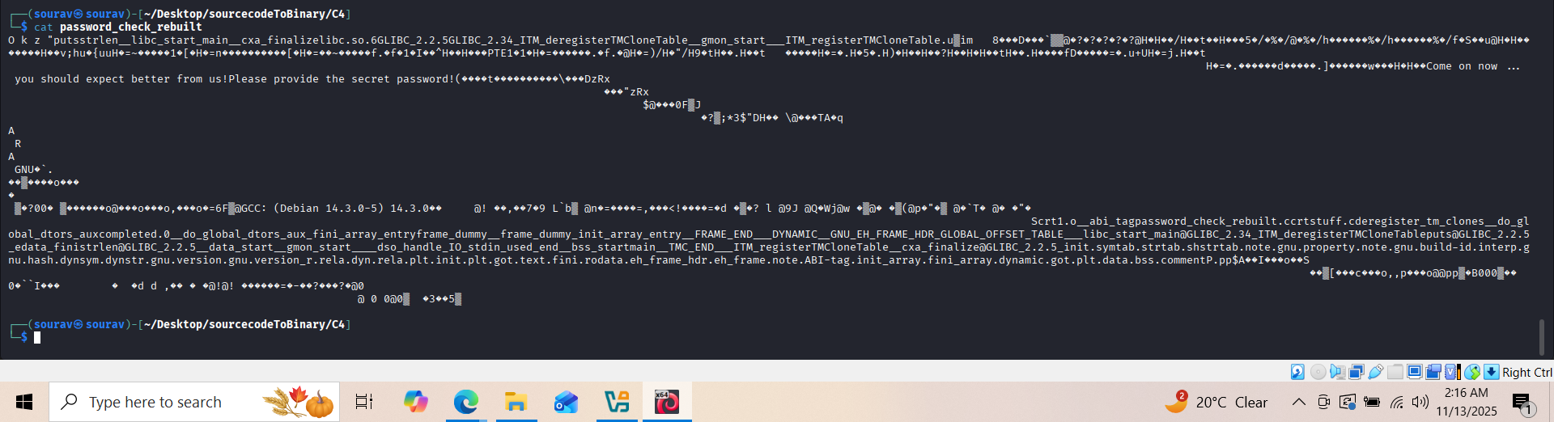

***TestResult:***

